Lab exercises for Week 2

1. Use Murphy, Myors & Wolach (2014) Appendix E to walk people through the main ideas of power analysis
   1. dfhyp is basically an index of the complexity of the problem. Compare 2 groups and dfhyp = 1; compare 5 groups and dfhyp = 1. Use seven X variables to predict Y and dfhyp = 6
   2. This table uses two alternative ways of indexing effect size, *d* and *PV*, or the percentage of variance explained
   3. Use *PV* = .01, .10 and .25 to represent small, moderately large and large effects, and find the value of dferror needed to have power of .80 (alpha=.05) for simple (dfhyp = 1), moderately complicated (dfhyp = 4) and more complicated (dfhyp = 10) questions
   4. Calculate sample size required (dfhyp + dferr + 1)

**PV = .01**: dfhyp =1; df err = 73.

Sample size required = 1 + 775 + 1 = ***777***

***PV = .01*** dfhyp = 4; df err = 1165

Sample size required = 4 + 1165 + 1 = ***1170***

**PV = .01** dfhyp = 10; dferr = 1580

Sample size required = 10 + 1580 + 1 = ***1591***

**PV = .10**: dfhyp =1; df err = 75.

Sample size required = 1 + 73 + 1 =***75***

***PV = .10*** dfhyp = 4; df err = 110

Sample size required = 4 + 110 + 1 = ***115***

**PV = .10** dfhyp = 10; dferr = 152

Sample size required = 10 + 152 + 1 = ***163***

**PV = .25**\*: dfhyp =1; df err = 27.

Sample size required = 1 + 27 + 1 = ***29***

***PV = .25\**** dfhyp = 4; df err = 110

Sample size required = 4 + 42 + 1 = ***47***

**PV = .25**\* dfhyp = 10; dferr = 152

Sample size required = 10 + 59 + 1 = ***70***

***\*Used .24***

“The distribution of the statistic *F* is complex, and it depends in part on the

degrees of freedom of the hypothesis or effect being tested (dfhyp) and the degrees of

freedom for the estimate of error used in the test (dferr).”

“Percentage of Variance (PV) in some variable or outcome that is explained as a general measure of effect size.”

1. Download G*Power
   1. Go through the tutorial with them
   2. Have them work out power for independent t-test and for ANOVA (F tests) with 4 groups
      1. Work out all five variations of power analysis (e.g.,compute N given ES, alpha etc)

**A-priori t-test**

Your advisor has recently found themselves in a busy mess and doesn’t have time to run a power analysis for the grant that is due *tonight!* Because you are an ambitious grad student, you take on the task. The study is a randomized control treatment assessing the differences in anxiety scores between participants that took a 12-week mindfulness meditation class vs. those in a control group. You are instructed to use an alpha level of .05 and a recent meta-analysis that came out has shown that mindfulness interventions and anxiety tend to show an effect size of 0.30. What sample size would be needed to achieve a power level of .80?

**Answer:**

* *Type of power analysis* = T-test: A-priori: Compute required sample size – given alpha, power & effect size
* Tails = 2
* Effect size d = .30
* Alpha = .05
* Sample size group 1 = 176
* Sample size group 2 = 176
* Total sample size = 352
* ***“Good” Response***: A total of 352 participants are needed to get a power level of .80
* 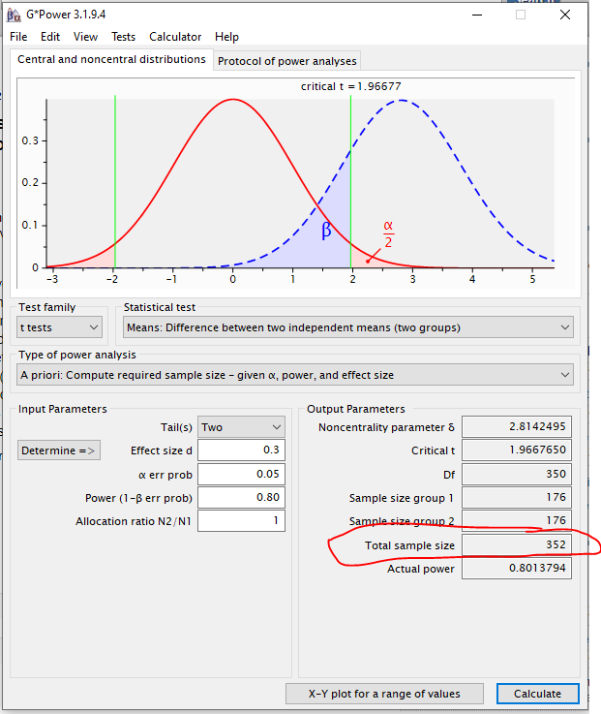

**Part 2:**

After giving your advisor your splendid power analyses, they tell you that they anticipate having 500 participants (250 in each condition). Using the same alpha level and effect sizes as before, what is the power of this study?

**Answer:**

Power = .93

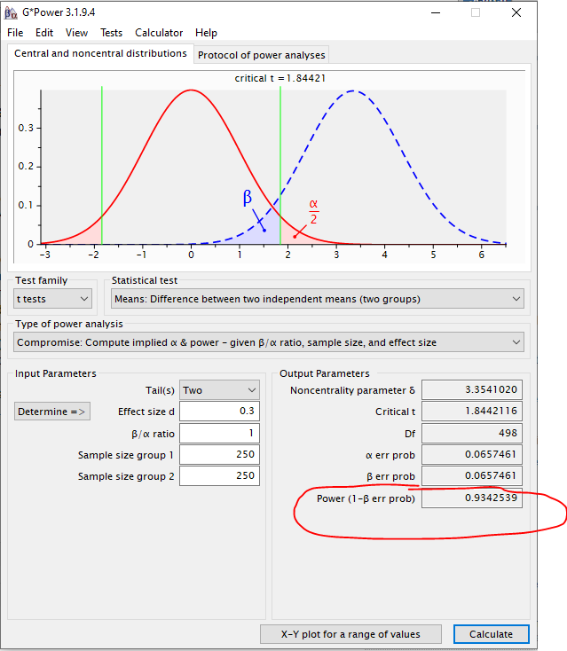

**A priori ANOVA (4 groups)**

An outside researcher heard you did a great job with your last power analyses and requested that you help them too. You, now a confident power analyst, agree to help. You are focused on a pilot study with 4 groups trying to see if different yoga interventions have any effect sustained attention in a college student population. For this study, college students will be randomly assigned to each group. Generally, the expected effect size for interventions like these on sustained attention is 0.15. Using an alpha value of .05, what sample size would be needed to obtain a power of .80?

**Answer:** 492

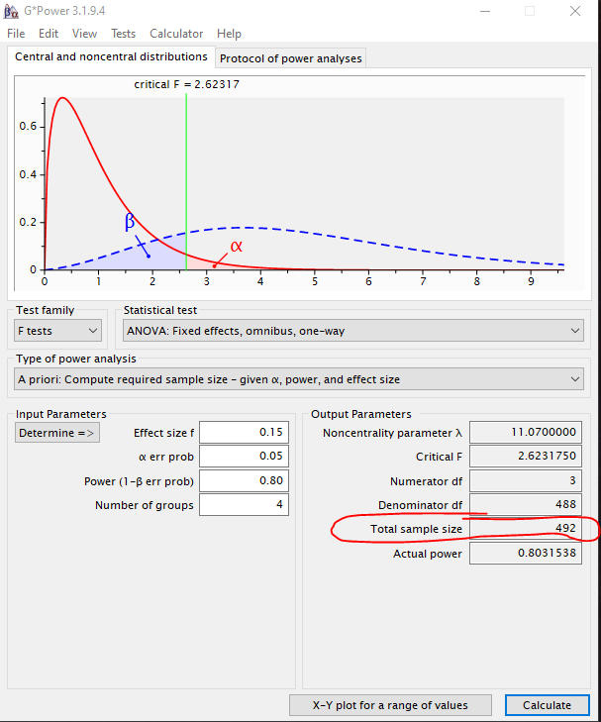

**Part 2:**

The outside researcher mentions that they simply do not have the resources to recruit that many participants for the study. Therefore, they ask advice on how to have the same power, but with less participants. What are 2 ways you could achieve this? Please explain the repercussion of each way described.

**Answer:**

1. Raise the alpha level: However, this will increase the chance of a type 1 error
2. Make the study less complex by reducing the number of comparison conditions. If we removed one of the yoga conditions in the study (so go from 4 groups to 3 groups), the number of participants required will detect the effect will be less.

**Post Hoc T-test**

A CSU faculty member recently finished up an experimental study and failed to find significance between their control and treatment group when alpha was set at .05. Devastated, because they were so positive that their treatment would work, they come to you to understand why they did not find any statistical significance in their results. Their completed study yielded an effect size of .30 between the two groups. The faculty members sample had 100 participants in each group. Can you provide this faculty member an explanation as to why they did not find statistically significant results, given their sample?

**Answer:**

* *Type of power analysis* = T-test: Post hoc: Compute achieved power given alpha, sample size and effect size
* Tails = 2
* Effect size d = .30
* Alpha = .05
* Sample size group 1 = 100
* Sample size group 2 = 100
* ***“Good” Response***: Your study was under powered, given the criteria you have provided, You only had a power level of .56, Therefore, there was only a 56% chance that you would have detected the true effect with statistical significance.